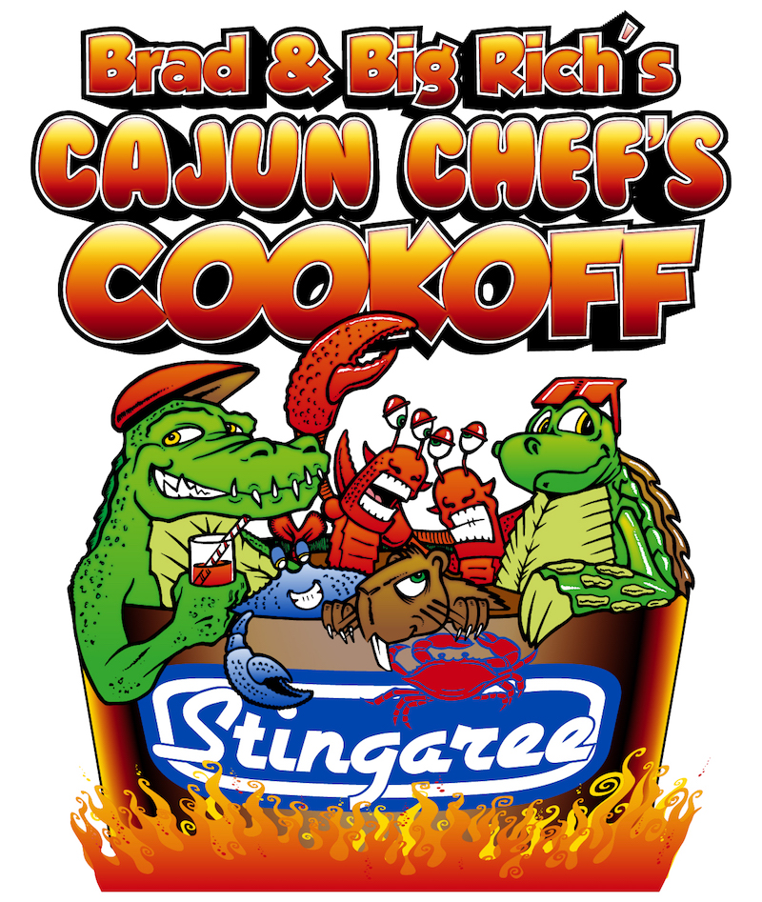
Brad & Big Rich’s Cajun Chef’s Cookoff
October 27 2018
Stingaree Restaurant and Marina
1295 N. Stingaree Rd Crystal Beach, Texas 77650
Cook-off- contact # 409-684-2731,9am-3pm

ENTRY LIMITED TO FIRST 10 TEAMS

Entry Fee $200 per team, 10 team limit.
Judged on- Bloody Mary, Seafood Gumbo and Chef’s Choice
Combination of 3 scores for 1st, 2nd and 3rd
Public votes thru ticket drop for “People Choice Award”
Trophies for 1-3rd and People’s Choice plus $500-1st, $250-2nd and $100-3rd place payout.

Each team will supply and serve 4 gal of Gumbo and 2 gal of Bloody Mary to attendees in supplied cups. All monies raised to include, Entry, T-Shirt Sales, Raffle and Public Choice Tickets Sold go to
The Holtzclaw Memorial Foundation.

Live Music All Day
Winners Announced at 2:30 pm at DownUnder Restaurant.
Brad and Big Rich’s Cajun Chef’s Cookoff
Sign-up Form (please print)

Team Name- _____________________________________________

Team Captain_____________________________________________

Contact# _____________________ Email- _____________________

Address- ________________________________________________

City ________________________ State _________ Zip __________

Entry Fee $200 (make checks payable to Stingaree Restaurant) check must be received with sign-up form by October 15th 2018. mail to P.O. Box 2356 Crystal Beach, Texas 77650 or dropped off at Stingaree Restaurant 1295 N. Stingaree Rd Crystal Beach Texas 77650, a conformation email will be sent once received.

Entry Fee Includes- Vodka for Bloody Mary Contest but must be poured by our bartender, one 10x10 serving area/cook area at Stingaree Restaurant. All sample cups sold to attendees along with Judging Containers will be supplied. Gumbo and Bloody Mary for public consumption will be served to public 11am- 2pm. (consumers of Bloody Mary must be 21 yrs. of age no sample cups will be sold to minors)

Judging Turned in as follows- Bloody Mary- 11am, Seafood Gumbo- 12pm, Chef’s Choice- 1pm
It is the team’s responsibility to have food to designated area for judging on time no more than 15 minutes before deadline. Containers will be supplied for Bloody Mary Pint Glass, Gumbo Bowl and Chef’s Choice must have enough for 5 judges. Presentation is part of the judging on Bloody Mary, Gumbo and Chef’s Choice, platters for Chef’s Choice will be supplied.
Team Captain or Team Member must attend Pre-cook-off meeting at 6:45 am at Stingaree Restaurant at DownUnder.

No Alcohol may be brought in or taken out of Stingaree Restaurant, Bloody Mary Vodka will be supplied but must be poured by our bartender. All alcohol for cooking or consumed must be purchased from Stingaree Restaurant or DownUnder Restaurant. No Exception!

Brad and Big Rich’s Cajun Chef’s Cookoff
Rules and Standards

Set-up can be done Saturday Morning at 6 am, Cooking Starts at 7 am and not before. Cookers Removed and Area Clean by 3:30 pm.

No Pre-cooked meats or vegetables, all cooking must be done on premises.

Submit Chef’s Choice item to be cooked ___________________________

____________________________________________________________

____________________________________________________________

Bloody Mary- Bloody Mary must be mixed in your cook-off teams serving area due to TABC rules. Vodka supplied must be supplied and poured by our bartender.
Gumbo must be Seafood Gumbo and include- Shrimp and Crab.
Chef’s Choice is your creation and must be of Cajun style plate.

Stingaree Restaurant will sign-up each team with Galveston County Health Department for Health Certificate 0nline. (www.gchd.org for this cook-off) All cooking must be off the ground. All Galveston County Health Department rules and regulations must be followed. Galveston County Health Department will inspect each cook-off area during cook-off.

Judging will be done in combination of Bloody Mary, Seafood Gumbo and Chef’s Choice. Scores will be tallied together for 1st, 2nd and 3rd place winners. Count of tickets for Public Choice Award winner. Containers will be supplied for serving booths for People’s Choice Award Vote Tickets.

All teams will be responsible for serving utensils for public serving and must supply 4 gals of Gumbo, 2 gals of Bloody Mary to be served. Gumbo and Bloody Mary served must be the same as judged, public will vote thru ticket drop for Public Choice Award. It’s the teams responsibility to keep track of ticket container supplied and must be turned in by 2:00pm for final count to designated area. Sample Cups sold to raise monies for Holtzclaw Memorial Foundation.

Sample cups for Gumbo and Bloody Mary may only be served in once. Any teams serving in a used container will be disqualified, no exceptions.

It is the Cook-off Teams responsibility to stay in compliance with all Galveston County Health requirements during this cook-off and during the time of serving samples to the public. GCHD will be inspecting all cook-off teams

All monies raised including Entry Fee, Shirt Sales, Sample Cup and Raffle Tickets will be donated to The Holtzclaw Memorial Foundation.

LIVE Auction will take place at 2:00pm for all items donated.
All monies raised from Live Auction/Silent Auction go to The Holtzclaw Memorial Foundation

People’s Choice tickets available day of event till 1:30pm, Tickets, 4-$20 or 25-$100

For any questions on this event please contact…
Stingaree Restaurant and Marina
409-684-2731

Brenda@Stingaree.com

webpage for cook-off…
www.bolivarpeninsulatexas.com/Events/Cajun-Cookoff

