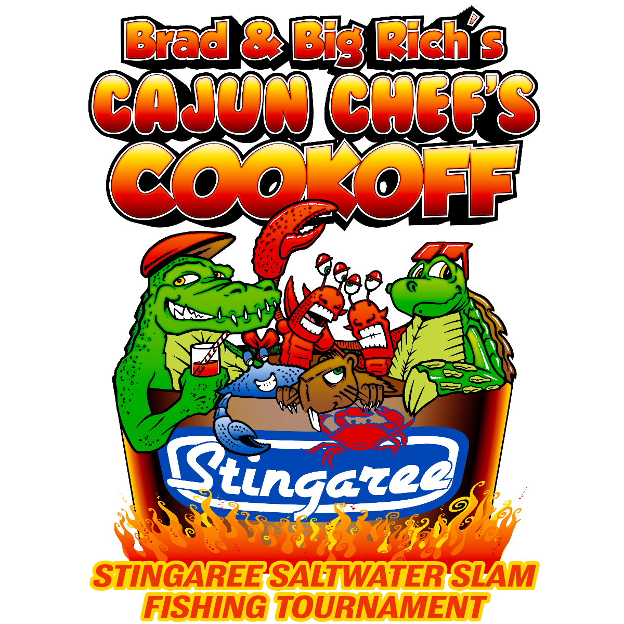
2023
Stingaree Slam Fishing
Tournament
October 14, 2023

TOURNAMENT PRESENTED BY:
Stingaree Restaurant & Marina
Guaranteed Cash Prize For 1st, 2nd, & 3rd Place; Big Fish Pot Cash 100% Payout
Individual Fee: $100 Team of 4: $350
Entries must be received by 10/13/2023 at 6:00 PM
*** Early entry fee discounts by 9/30/23
Individual Fee: $75 Team of 4: $300
Kids Hardhead Haul-In - FREE - Children 12 & under ( must be accompanied by adult)

Location: Stingaree Restaurant & Marina Crystal Beach, Tx
Time: Friday, October 13, 6:00 am - 3:00pm

Friday October 13 at Stingaree Down Under
6:00 pm Check In/Registration
7:00 pm Calcutta
*Appetizers will be served

Saturday October 14 at Stingaree Restaurant & Marina
8:30 am Kid’s start time
9:00 am - 10:00 am Kid’s weigh In
10:30 am Kid’s award ceremony
12:00 pm - 3:00 pm Lunch @ Stingaree
1:30 pm - 3:00 pm Official Weigh In by CCA Saltgrass
4:00 pm Awards Ceremony and Door Prizes
11am - 3 pm Live music
__________________________________________________________________________________________________

Capt Name ____________________________ Address ______________________________ Ph___________________
Angler Name __________________________ Address ____________________________________________________
Angler Name __________________________ Address ____________________________________________________
Angler Name __________________________ Address ____________________________________________________
Capt Email 1.) __________________________________________ S M L XXL XXXL
Angler Email 2.) ________________________________________ S M L XXL XXXL
Angler Email 3.) ________________________________________ S M L XXL XXXL
Angler Email 4.) ________________________________________ S M L XXL XXXL

Please clip & mail this completed form before September 30, 2023 with check payable to Texas Crab Festival Charities. Mail to Stingaree Restaurant PO Box 2356 Crystal Beach, Tx 77650. For questions contact Brenda: 409-291-9092

**!! ALL PROCEEDS GO TO THE TEXAS CRAB FESTIVAL CHARITIES !!**
Fishing Rules
Registration & Entry Fees:
Team Tournament — Maximum of 4 fishermen to a team. Multiple Boats and kayaks can be used. Fees: Team fee (4): $350.00, Individual entries: $100.00
**early entry fee discount (received by 9/30/23) Individual: $75 Team of 4: $300

All entry fees must be paid by 10/13/23 by 6:00 PM. Entry Fee includes all meals, awards, and goodie bags. Souvenir shirts and caps can be purchased.
Registration will take place at Stingaree Down Under at 6:00 PM, prior to the Calcutta, but is not required.

Fishing Rules:
All Anglers must have a valid Texas Fishing License and Saltwater Stamp. All Texas Parks and Wildlife rules must be observed. Boats may leave the dock 6:00 am on October 14, 2023. Natural or artificial bait may be used.
3 Trout (limit of on trout over 25” per team), 2 slot redfish and 1 flounder will be weighed per team. Winners will be determined by total weight of the catch (maximum of 6 fish). Ties will be broken by check-in times.
Winners may be subject to polygraph. Cash prizes may not be awarded until authenticity of catch is determined.
Tournament boundaries are the surf from High Island @ HWY 124 West to San Luis and Galveston Bay complex. Entries can begin at daylight October 14th.

Weighing:
Official weigh in will take place from 1:30 pm to 3:00 pm at Stingaree Restaurant & Marina and will be administered by the CCA Saltgrass. NO EXCEPTIONS!

Prizes and Payouts:
Heaviest Stringer:
- 3 Speckled Trout, 2 Redfish, 1 Flounder
    - 1st Place: $2,000
    - 2nd place: $1,000
    - 3rd Place: $500
- Big Fish Pot Cash 100% payout

Awards ceremony will take place at Stingaree Restaurant & Marina at 4 pm.

Kids Hardhead Haul-In 12 yrs old and under

- Heaviest Hardhead wins a $500.00 scholarship

Kids can start fishing at 8:30 am. Weigh-in will be between 9:00 am - 10:00 am. Awards ceremony for kids will be
@ 10:30 am. Hot dogs and drinks will be served.
2023
Stingaree Slam Fishing
Tournament
October 14, 2023

TOURNAMENT PRESENTED BY:
Stingaree Restaurant & Marina
Guaranteed Cash Prize For 1st, 2nd, & 3rd Place; Big Fish Pot Cash 100% Payout
Individual Fee: $100 Team of 4: $350
Entries must be received by 10/13/2023 at 6:00 PM
*** Early entry fee discounts by 9/30/23
Individual Fee: $75 Team of 4: $300
Kids Hardhead Haul-In - FREE - Children 12 & under ( must be accompanied by adult)

Location: Stingaree Restaurant & Marina Crystal Beach, Tx
Time: Friday, October 13, 6:00 am - 3:00pm

Friday October 13 at Stingaree Down Under
6:00 pm Check In/Registration
7:00 pm Calcutta
*Appetizers will be served

Saturday October 14 at Stingaree Restaurant & Marina
8:30 am Kid’s start time
9:00 am - 10:00 am Kid’s weigh In
10:30 am Kid’s award ceremony
12:00 pm - 3:00 pm Lunch @ Stingaree
1:30 pm - 3:00 pm Official Weigh In by CCA Saltgrass
4:00 pm Awards Ceremony and Door Prizes
11am - 3 pm Live music
__________________________________________________________________________________________________

CHILD’S Name: _______________________________________
PARENT’S Name: ______________________________________
PHONE: ______________________________________________
ADDRESS: ___________________________________________

SHIRT SIZE: __________________________________________ S M L A(S) A(M)

No Entry Fee For Kids
Please clip & mail this completed form before September 30, 2023 with check payable to Texas Crab Festival Charities. Mail to Stingaree Restaurant PO Box 2356 Crystal Beach, Tx 77650. For questions contact Brenda: 409-291-9092

**!! ALL PROCEEDS GO TO THE TEXAS CRAB FESTIVAL CHARITIES !!**

